Waukegan Bowmen of Bristol, WI
An Archery Tradition since 1947
Founded in Waukegan, IL, located since 1969 in beautiful Bristol, WI
20714 – 107th Street (Hwy JS), Bristol, WI
NATIONAL ARCHERY DAY!!
Saturday, May 11, 2024

TO COMMEMORATE THIS DAY
KIDS ARE FREE !
AGES : (15&UNDER)
*Parents must accompany kids.
*Sorry parents, kids day! parents gotta pay.

30 stations with a 3D animal targets on our beautiful wooded outdoor ranges. Traditional, recurve, and compound bows welcome!

OPEN TO THE PUBLIC!
Registration: Saturday 7:30am to 3:00pm
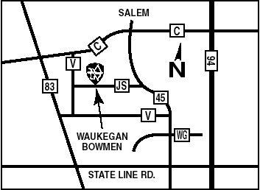  On JS, west of Hwy 45 | Adult WBM Club $10.00  Adult non-WBM $15.00  Kitchen open 7:30am to 2:00pm  Breakfast and Lunch and a  Selection of beverages are available for purchase
Upcoming 2024 Waukegan Bowmen 3D Shoots
Outdoor 3D Shoot - June 8th & 9th
Outdoor 3D Shoot – July 20th & 21st
Outdoor Hunter’s Prep Shoot – August 10th & 11st
Indoor Halloween Shoot – October 26th & 27th
www.waukeganbowmen.com
and on Facebook!

